

Semester One Examination, 2022

Question/Answer booklet

MATHEMATICS METHODS
UNIT 3

Section One:

Calculator-free

Your Name:
Your Teacher’s Name:

Time allowed for this section
Reading time before commencing work: five minutes
Working time: fifty minutes

Materials required/recommended for this section
To be provided by the supervisor
This Question/Answer booklet
Formula sheet

To be provided by the candidate
Standard items: pens (blue/black preferred), pencils (including coloured), sharpener, correction fluid/tape, eraser, ruler, highlighters

Special items: nil

Important note to candidates
No other items may be taken into the examination room. It is your responsibility to ensure that you do not have any unauthorised material. If you have any unauthorised material with you, hand it to the supervisor before reading any further.

Question | Marks | Max | Question | Marks | Max
1 |  | 8 | 5 |  | 6
2 |  | 10 | 6 |  | 13
3 |  | 8
4 |  | 8

Structure of this paper

Section | Number of questions available | Number of questions to be answered | Working time (minutes) | Marks available | Percentage of examination
Section One:  Calculator-free | 6 | 6 | 50 | 53 | 35
Section Two:  Calculator-assumed | 10 | 10 | 100 | 100 | 65
 |  |  |  | Total | 100

Instructions to candidates

- The rules for the conduct of the Western Australian Certificate of Education ATAR course examinations are detailed in the Year 12 Information Handbook 2019. Sitting this examination implies that you agree to abide by these rules.

- Write your answers in this Question/Answer booklet.

- You must be careful to confine your answers to the specific questions asked and to follow any instructions that are specific to a particular question.

- Additional pages for the use of planning your answer to a question or continuing your answer to a question have been provided at the end of this Question/Answer booklet. If you use the space to continue an answer, indicate in the original answer space where the answer is continued, i.e. give the page number.

- Show all your working clearly. Your working should be in sufficient detail to allow your answers to be checked readily and for marks to be awarded for reasoning. Incorrect answers given without supporting reasoning cannot be allocated any marks. For any question or part question worth more than two marks, valid working or justification is required to receive full marks. If you repeat any question, ensure that you cancel the answer you do not wish to have marked.

- It is recommended that you do not use pencil, except in diagrams.

- The Formula sheet is not to be handed in with your Question/Answer booklet.

Section One: Calculator-free (53 marks)

This section has six questions. Answer all questions. Write your answers in the spaces provided.

Spare pages are included at the end of this booklet. They can be used for planning your responses and/or as additional space if required to continue an answer.
● Planning: If you use the spare pages for planning, indicate this clearly at the top of the page.
● Continuing an answer: If you need to use the space to continue an answer, indicate in the original answer space where the answer is continued, i.e. give the page number. Fill in the number of the question that you are continuing to answer at the top of the page.

Working time: 50 minutes.

Question 1 (8 marks)
The function $f$ is defined for $x>0$ by $f\left(x\right)=\begin{matrix}e^{4x-1} \\ \overline{ \overset{ }{x} }\end{matrix}$, and $f^{''}\left(x\right)=\begin{matrix}2\left(8x^{2}-4x+1\right)e^{4x-1} \\ \overline{{ x}^{3} }\end{matrix}$.

- Show that $f'(x)=\frac{e^{4x-1}\left(4x-1\right)}{x^{2}}$ (2 marks)

- Determine the coordinates and nature of all stationary points of $y=f(x)$. Justify your answer. (4 marks)

- Show that $y=f(x)$ has no points of inflection. (2 marks)

Question 2 (10 marks)

The discrete random variable $X$ has a probability function with $Var(X) =\frac{14}{9}$
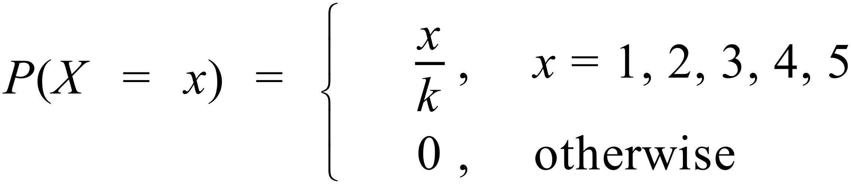

(a) Determine the value of $k$ (2 marks)

Determine:

(b) (i) $P(X<4 | X>1)$ (2 marks)

(ii) $E(X)$ (2 marks)

(c) A second discrete random variable $Y$ is defined to be $Y=aX+b.$
If $E(Y)=2$ and the standard deviation of $Y$ is$\sqrt{14}$, determine $a$ and $b$. (4 marks)

Question 3 (8 marks)
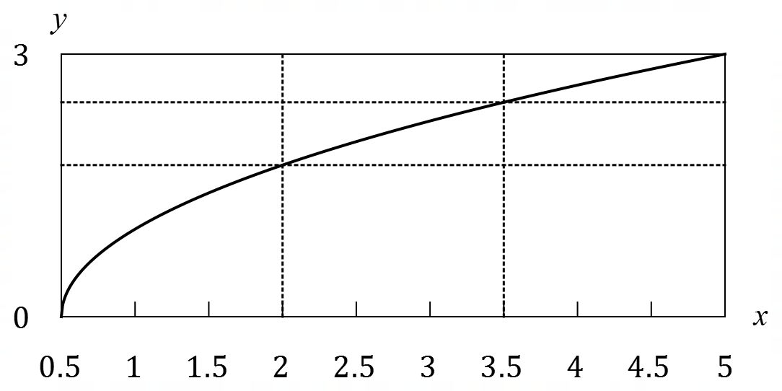
The graph of $y=\sqrt{2x-1}$ between
$x=0.5$ and $x=5$ is shown at right.
Approximate values for $\sqrt{3}$ and $\sqrt{6}$
are $1.73$ and $2.45$ respectively.

(a) Use the areas of the rectangles shown to explain why $6.27<\int_{0.5}^{5}{\underset{ }{\overset{ }{\sqrt{2x-1}}}}dx<10.77$. (3 marks)

(b) Evaluate $\int_{0.5}^{5}{\underset{ }{\overset{ }{\sqrt{2x-1}}}}dx$. (3 marks)

(c) Evaluate $\int_{0.5}^{5}{\left(\underset{ }{\overset{ }{\sqrt{2x-1}}}-3\right)}dx$. (2 marks)

Question 4 (8 marks)

A student observes the graphs of three binomial distributions with the assigned random variables $A,B$ and $C$ for each graph. For all three distributions, the value of $n$ is constant, but the values of $p$ are 0.25, 0.5 and 0.9 respectively.

- The student notes that one of the distributions produced a graph that is skewed to the right (long tail to the right). Which of the values of $p$ were used to produce this graph? Give justification for your choice. (2 marks)

- The standard deviation when $p=0.25$ is 6. Determine the value of $n$. (3 marks)

- Using your answer from part b), show how to calculate the following without the use of a calculator. Do not evaluate your answer.

  - $P(A=4)$ (1 mark)

  - $P(C≥190)$ (2 marks)

Question 5 (6 marks)
- Determine $\frac{d}{dx}(\cos^{3}\left(4x\right))$ (2 marks)

- Hence, evaluate the following in exact form: $\int_{0}^{\frac{π}{3}}{-sin 4x cos^{2}\left(4x\right)dx}$ (4 marks)

Question 6 (13 marks)

The graph of $g\left(x\right)$ is given as below, which consists of a semi-circle for $-7≤x≤-1$ and a triangle for $-1≤x≤8.$
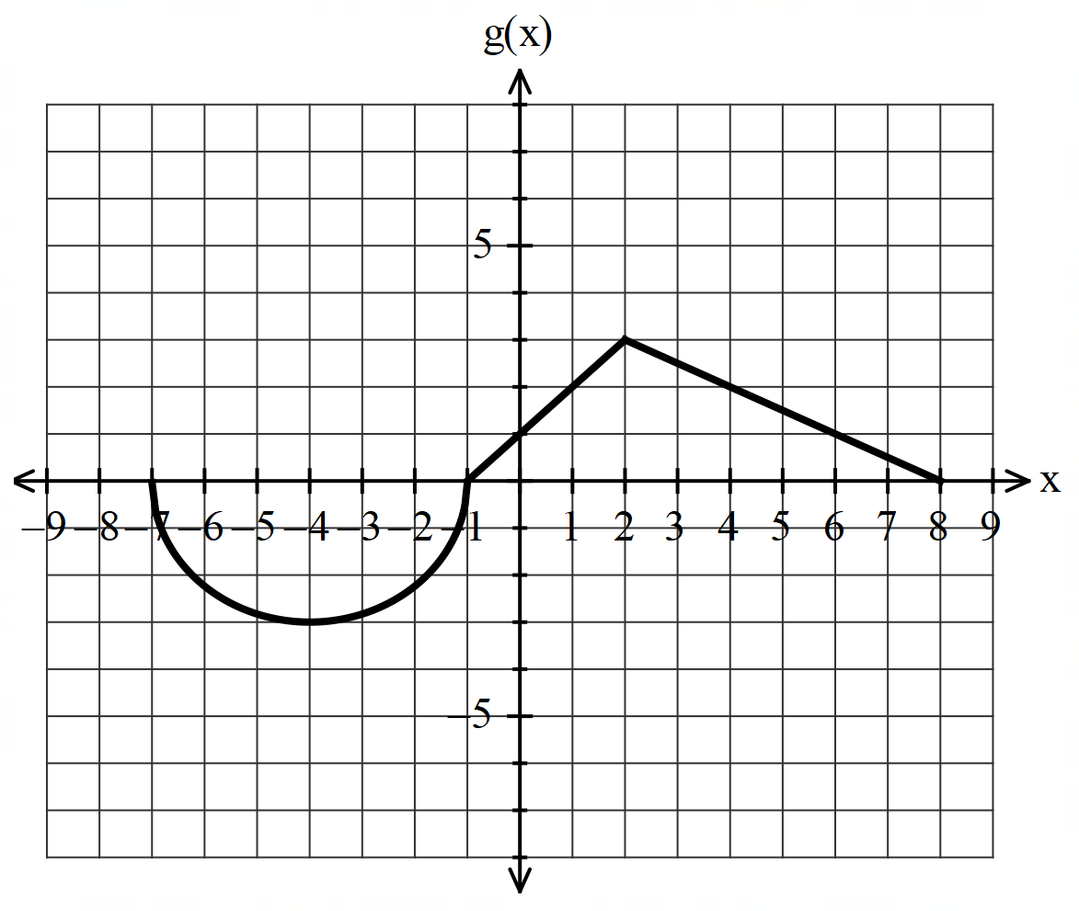

Given that $f\left(x\right)=\int_{-7}^{x}{g\left(t\right) dt}$, where $-7≤x≤8$.
- Determine the intervals where $f(x)$ is increasing and decreasing, respectively.
(2 marks)

- Determine the intervals where $f(x)$ is concave up and concave down, respectively.
(2 marks)

- Determine the value(s) of $x$ when $f\left(x\right)$reaches any stationary point(s) and the nature of the stationary point(s), if any. (2 marks)

- Determine the exact values of $f\left(-1\right)$. (2 marks)

- Determine the exact values $f(8)$. (2 marks)

- Sketch the graph of $f(x)$ in the axes provided below, for $-7≤x≤8.$ Label key features. (3 marks)
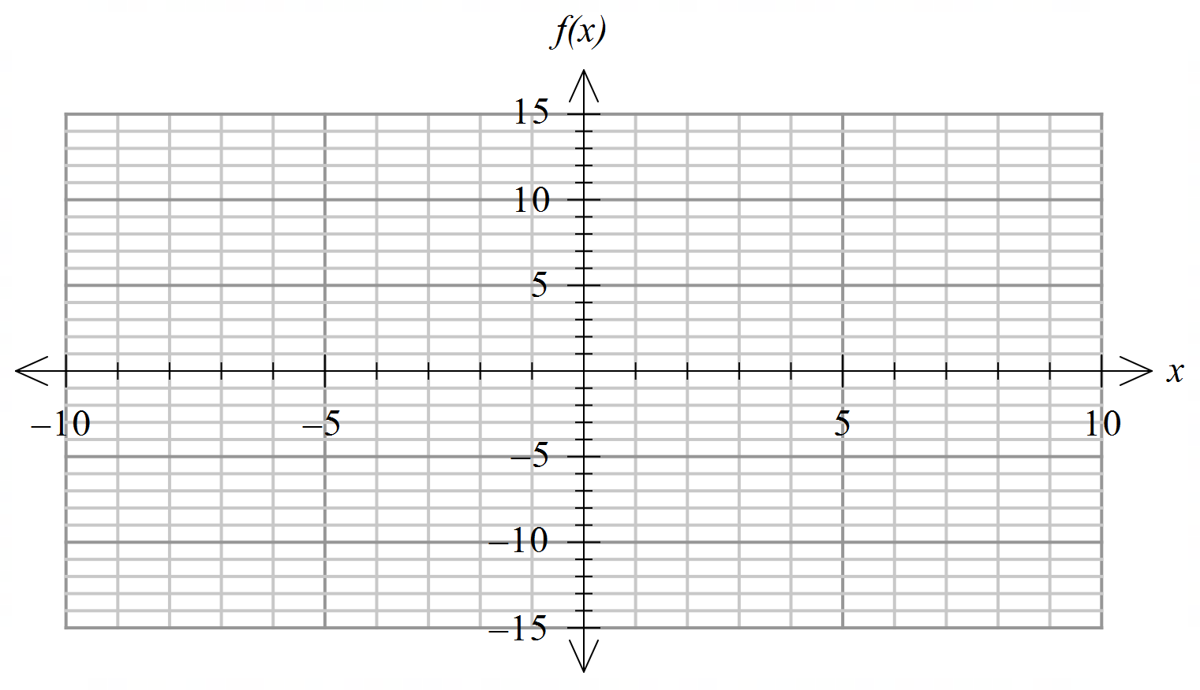

Additional working space
Question number: ________

Additional working space
Question number: _____

